FRIDAY, JUNE 25, 2021

Federal Government called to investigate environmental impacts of artificial turf and more environmentally appropriate alternatives for sporting surfaces
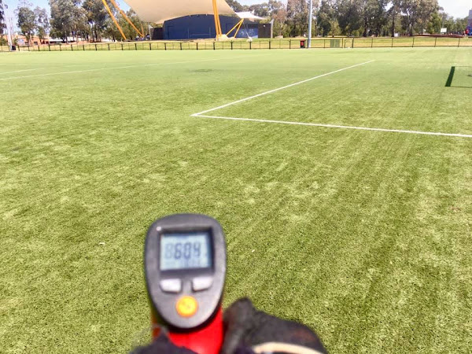
Conversion of grass sporting fields to Synthetic Turf... The Australian Local Government Association (ALGA) National Conference was held in Canberra last weekend 20-23 June 2021 and passed a motion unanimously "to investigate the environmental impacts of artificial turf and more environmentally appropriate alternatives for sporting surfaces."
Issue 24 submitted by Mitcham Council, SA
That the National General Assembly calls on the Federal Government to investigate the environmental impacts of artificial turf and more environmentally appropriate alternatives for sporting surfaces.
The resolution was passed unanimously, including by the Moreland Councillors in attendance: Cr Adam Pulford, Cr Lambros Tapinos, Cr Oscar Yildiz, Cr Helen Pavlidis and Cr Angelica Pandopolous.

OBJECTIVE
The objective of the motion is to secure funding and delivery of a national decision framework to be used by State and Local Governments to inform decisions relating to artificial vs natural turf sport surfaces.
The project will also fund research and development into how the negative impacts of artificial turf can be overcome in consultation with artificial turf manufacturers, landscape designers and open space managers. This links to the challenges outlined by Australia National Outlook 2019 released by the CSIRO:
A broad range of impacts will be experienced in Australia because of global climate change, the severity of which will depend on the effectiveness of global emission reductions and local adaptation. These impacts will increase stress on Australia’s ecosystems that are already threatened, and significantly affect agriculture, forestry, fisheries, transport, health, tourism, finance and disaster risk management. It is possible to strive towards zero emissions through a range of actions that target key sectors including energy, land use, urban infrastructure, and industrial systems.
KEY ARGUMENTS
Sporting and community clubs across the country are receiving grants to install artificial turf for sports fields and there are several pipeline projects about to hit the City of Mitcham for approval. Most councils currently do not have formal policy positions on “artificial vs natural” turf within open space and sports and recreation areas. Awareness of the strengths and weaknesses in relation to artificial and natural turf type selections (as flagged by a range of information the Department of Local Government, Sport and Cultural Industries in Western Australia “Natural Grass vs Synthetic Turf Decision Making Guide”) is limited. A recent Adapt West Heat Mapping study in South Australia also revealed that artificial turf was eight degrees warmer than average surface temperatures across the region. The health of current and future sports field / open space users, given projected increases in extreme heat, as well as the potential creation of heat islands impacting the surrounding community are of concern.
Other studies have also revealed that artificial turf has a higher carbon footprint and contributes to waste to landfill as it currently cannot be recycled. Given the time spent to research and debate the issue within the City of Mitcham and the polarised views in the community, City of Mitcham intend to raise the issue (in parallel to this motion) with the Department of Environment and Water (DEW), the Office of Open Space, Recreation and Racing and the South Australian Local Government Authority (SA LGA). These discussions to include ascertaining interest in pursuing further research and development in this area as well as the development of a wider decision framework which considers the economic, social and environmental criteria to help guide how projects are approved and delivered.
============
Moreland Council voted against a report at the April 2021 Council meeting into the triple bottom line assessment of economic, social and environmental costs, benefits and impacts of installing synthetic Turf, yet they have several projects in the pipeline for conversion.
Cr Lambros Tapinos, Cr Oscar Yildiz, Cr Helen Pavlidis all voted for the above motion by ALGA, yet opposed the motion for an independent report by Moreland Council.
Sign the petition for Moreland Council to commission an independent report so they can make decisions on synthetic turf based on good governance not google.
https://www.petitions.net/moreland_council_commission_an_independent_report_on_synthetic_turf_impacts
Background:
- Literature Review: Synthetic Turf carbon footprint, environmental, health, microplastics and biodiversity impacts
- Annotated Bibliography on Synthetic Turf and Climate, health, biodiversity and microplastics pollution issues
- Sustainable sports fields are natural turf not synthetic in a time of climate emergency

